

Relationships and Sex Education (RSE) Policy


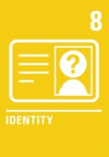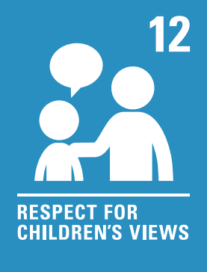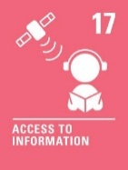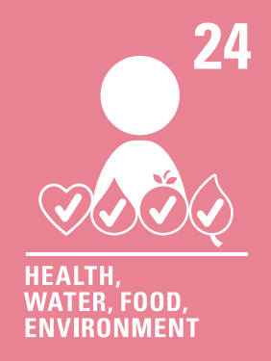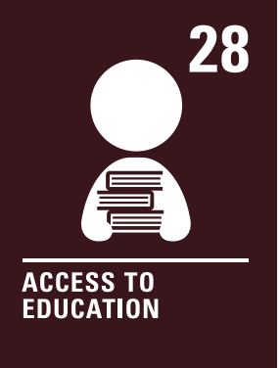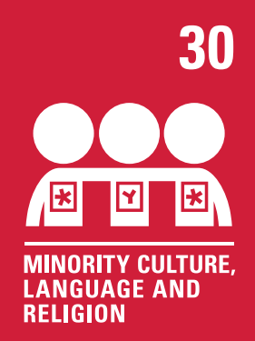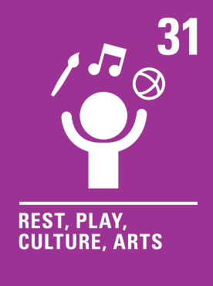

Contents:
Statement of intent
1. Policy ownership, approval and review.
2. Policy statement and school ethos.
3. Legislative and statutory framework.
4. Policy development and stakeholder consultation.
5. Curriculum design and implementation.
6. Staff training and support.
7. Monitoring, evaluation and quality assurance.
8. Safeguarding, confidentiality and pupil well-being.
9. Parental engagement and communication.
10. Policy review and update procedures.
11. Appendices and supporting materials.
12. References.

1.1 Policy Owner and Responsible Staff
This policy is owned by Rachel Tomlinson, Headteacher of Barrowford School. The designated lead for RSE is Rachel Tomlinson, who is responsible for the development, implementation, and review of this policy. The governing body of Barrowford School provides oversight and ensures compliance with statutory requirements.
1.2 Approval and Review History
This policy was approved by the Governing Body of Barrowford School on [Date of Policy Approval].
The policy will be reviewed annually, or sooner if required by changes in legislation or statutory guidance. The review process will involve consultation with stakeholders, including parents, pupils, staff, and governors. Records of all reviews, consultations, and updates will be maintained by the designated lead.
2.0 Policy Statement and School Ethos
2.1 Purpose and Scope
The purpose of this policy is to set out Barrowford School’s approach to Relationships and Sex Education (RSE) in line with statutory requirements and best practice guidance. This policy applies to all pupils, staff, governors, and parents/carers at Barrowford School. It covers the delivery of Relationships Education in primary phases, as required by the Children and Social Work Act 2017 and the Relationships Education, Relationships and Sex Education and Health Education (England) Regulations 2019.
RSE at Barrowford School is designed to equip pupils with the knowledge, skills, and values necessary to form healthy, respectful relationships, understand human sexuality, and make informed decisions about their wellbeing. The policy ensures that RSE is delivered in a way that is age-appropriate, inclusive, and responsive to the needs of our diverse school community.
2.2 School Ethos and Values
At Barrowford School, we are committed to providing an inclusive, accessible, and high-quality RSE curriculum that reflects our school ethos and values. We believe that all pupils have the right to receive accurate, balanced information about relationships and sex, which supports their personal development, wellbeing, and safety.
Our approach to RSE is underpinned by the principles of respect, equality, and safeguarding. We recognise and celebrate the diversity of our school community, ensuring that RSE is sensitive to the needs of all pupils, including those with special educational needs and disabilities (SEND), those from different cultural or religious backgrounds, and those who identify as lesbian, gay, bisexual, or transgender (LGBT).
We are committed to upholding the requirements of the Equality Act 2010, ensuring that our RSE provision eliminates discrimination, advances equality of opportunity, and fosters strong relationships between all members of our school community. RSE at Barrowford School is delivered in a safe, supportive environment, where pupils feel able to ask questions, express their views, and develop the confidence to make positive choices.
2.3 Policy Accessibility
This policy is available to all parents, carers, staff, and pupils via the Barrowford School website. Printed copies are available on request from the school office. Information about the policy and any updates will be communicated through school newsletters, parent meetings, and other appropriate channels.
3.0 Legislative and Statutory Framework
3.1 Relevant Legislation and Statutory Guidance
Our RSE provision is guided by the following key legislation and statutory guidance:
- Education Act 1996 (as amended): Requires maintained secondary schools to provide sex education.
- Children and Social Work Act 2017: Makes Relationships Education compulsory in all primary schools and Relationships and Sex Education compulsory in all secondary schools.
- Relationships Education, Relationships and Sex Education and Health Education (England) Regulations 2019: Sets out statutory requirements for RSE.
- Equality Act 2010: Requires schools to eliminate discrimination, advance equality of opportunity, and foster good relations.
- DfE Statutory Guidance (2019, updated 2021): Provides detailed requirements for the content and delivery of RSE.
Barrowford School is committed to meeting all statutory obligations, including:
- Publishing this policy online and making it available to parents and carers.
- Consulting parents and carers in the development and review of this policy.
- Reviewing the policy annually, or more frequently if required.
- Ensuring that RSE is delivered in accordance with the law and statutory guidance.
3.2 Parental Rights and Withdrawal Procedures
Parents and carers have the right to request that their child be withdrawn from some or all of the sex education delivered as part of statutory RSE in secondary school. This right does not apply to Relationships Education in primary school or to any content that is part of the National Curriculum for science.
Requests for withdrawal should be made in writing to the Headteacher (Rachel Tomlinson). The Headteacher will invite the parent/carer to discuss the request, clarify the nature and purpose of the curriculum, and explain the benefits of receiving RSE.
Alternative provision will be arranged for pupils withdrawn from RSE, ensuring that their learning and wellbeing are not adversely affected. Records of all withdrawal requests and decisions will be maintained by the school.
3.3 Safeguarding and Confidentiality
RSE at Barrowford School plays a vital role in safeguarding pupils by equipping them with the knowledge and skills to recognise and report abuse, understand consent, and develop healthy relationships. All staff involved in delivering RSE receive training in safeguarding and child protection procedures.
If a pupil makes a disclosure during an RSE lesson, staff will follow the school’s safeguarding and child protection policy. Confidentiality will be maintained as far as possible, but staff cannot promise absolute confidentiality if a pupil is at risk of harm. Any concerns will be reported to the Designated Safeguarding Lead (Rachel Tomlinson) in line with statutory requirements.
4.0 Policy Development and Stakeholder Consultation
4.1 Stakeholder Engagement
The development and review of this policy are informed by consultation with a wide range of stakeholders, including parents, carers, pupils, staff, governors, and representatives from relevant community organisations. Consultation methods include surveys, focus groups, parent forums, and pupil voice activities.
Feedback from stakeholders is used to shape the content, delivery, and evaluation of RSE, ensuring that it meets the needs of our school community and reflects local context and values. Ongoing engagement is encouraged through regular communication, opportunities for feedback, and involvement in policy review.
4.2 Record-Keeping and Documentation
Barrowford School maintains comprehensive records of all stakeholder consultations, policy reviews, and parental withdrawal requests. These records are stored securely and are available for inspection by regulatory bodies such as Ofsted. Documentation includes minutes of meetings, survey results, correspondence with parents, and records of policy updates.
5.0 Curriculum Design and Implementation
5.1 Curriculum Intent and Principles
The aim of RSE at Barrowford School is to provide pupils with the knowledge, skills, and values they need to develop healthy, respectful relationships, understand human sexuality, and make informed decisions about their wellbeing. Our RSE curriculum is designed to:
- Be age-appropriate and developmentally appropriate, building knowledge and skills progressively from early years through to Year 6.
- Be inclusive of all pupils, including those with SEND and those from diverse backgrounds, ensuring that everyone can access and benefit from RSE.
- Cover statutory content as set out in DfE guidance, including families, respectful relationships, online relationships, being safe, and, at secondary level, intimate and sexual relationships, sexual health, and contraception.
- Promote equality, respect, and understanding of difference, including LGBT inclusion, in line with the Equality Act 2010.
- Support safeguarding by teaching pupils how to recognise unhealthy relationships, understand consent, and seek help if needed.
- Foster resilience, self-esteem, and confidence, enabling pupils to make positive choices and manage risks.
5.2 Curriculum Structure and Content Overview
RSE is delivered as part of a broad and balanced Personal, Social, Health and Economic (PSHE) education programme. The curriculum follows a spiral model, revisiting key themes at increasing levels of depth and complexity as pupils progress through the school.
Key Stage 1 and 2 (Primary):
- Families and people who care for me
- Caring friendships
- Respectful relationships
- Online relationships
- Being safe
- Physical health and mental wellbeing (as part of Health Education)
The curriculum is adapted to meet the needs of our pupils, taking into account local context, pupil voice, and current issues. RSE is integrated with other curriculum areas, such as science, computing, and religious education, to provide a coherent learning experience.

5.3 Teaching and Learning Approaches
RSE at Barrowford School is delivered using evidence-based, interactive teaching methods that promote active learning and pupil engagement. Approaches include:
- Class discussions, group work, and role play to explore scenarios and develop communication skills.
- Use of stories, case studies, and real-life examples to make learning relevant and relatable.
- Question boxes and anonymous opportunities for pupils to ask questions safely.
- Establishment of clear ground rules to create a safe, respectful learning environment.
- Differentiated activities and resources to meet the needs of all learners, including those with SEND.
Teachers receive training in delivering sensitive topics and managing discussions in a way that respects diverse perspectives and experiences. The curriculum is designed to challenge stereotypes, promote critical thinking, and encourage pupils to reflect on their values and beliefs.
5.4 Resources and Materials
All teaching resources and materials used in RSE are carefully selected to ensure they are accurate, up-to-date, and appropriate for the age and maturity of pupils. Barrowford School uses resources recommended by the PSHE Association, Sex Education Forum, and other reputable organisations.
Resource selection is overseen by the RSE lead, in consultation with staff, parents, and, where appropriate, pupils. Resources are reviewed regularly to ensure they reflect current guidance, best practice, and the needs of our school community. Parents are informed about the resources used and are welcome to view materials on request.
5.5 Inclusion and Accessibility
Barrowford School is committed to ensuring that RSE is accessible to all pupils, including those with SEND, those from different cultural or faith backgrounds, and those who identify as LGBT. Strategies to promote inclusion and accessibility include:
- Differentiating content and teaching methods to meet individual needs.
- Providing additional support and resources for pupils who require it.
- Consulting with parents and carers to understand and address specific needs or concerns.
- Making reasonable adjustments to ensure that all pupils can participate fully in RSE lessons.
- Ensuring that RSE reflects the diversity of our school community and promotes respect for all.
Staff receive training in inclusive practice and are supported to adapt their teaching to meet the needs of all learners.
6.0 Staff Training and Support
6.1 Staff Roles and Responsibilities
The delivery of RSE is a whole-school responsibility, involving teaching staff, support staff, and the leadership team. The designated RSE lead (Rachel Tomlinson) is responsible for:
- Overseeing the development and implementation of the RSE curriculum.
- Supporting staff with planning, delivery, and assessment of RSE.
- Coordinating staff training and professional development.
- Monitoring and evaluating the effectiveness of RSE provision.
Class teachers are responsible for delivering RSE in line with the agreed curriculum and policy, creating a safe and supportive learning environment, and responding to pupils’ questions and concerns. Support staff may assist in lessons and provide additional support for pupils with specific needs.
All staff have a duty to promote the school’s ethos and values, uphold safeguarding responsibilities, and model respectful, inclusive behaviour.
6.2 Training and Professional Development
Barrowford School is committed to providing regular, high-quality training and professional development for all staff involved in RSE. Training covers:
- Statutory requirements and best practice in RSE delivery.
- Safeguarding and child protection procedures.
- Inclusive practice and meeting the needs of diverse learners.
- Managing sensitive topics and responding to disclosures.
- Use of approved resources and teaching materials.
Staff have access to up-to-date guidance, resources, and support from the RSE lead and external organisations such as the PSHE Association. Training needs are identified through staff feedback, lesson observations, and curriculum reviews. Records of staff training are maintained and reviewed annually.
7.0 Monitoring, Evaluation, and Quality Assurance
7.1 Monitoring Arrangements
The quality and effectiveness of RSE provision are monitored through a range of systems, including:
- Lesson observations and learning walks by the RSE lead and senior leaders.
- Review of curriculum plans, resources, and pupil work.
- Analysis of pupil progress and attainment in RSE-related learning outcomes.
- Feedback from pupils, parents, and staff.
Monitoring ensures that RSE is delivered in line with statutory requirements, school policy, and best practice. Findings are used to inform curriculum development and staff training.
7.2 Evaluation and Impact Assessment
The impact of RSE is evaluated through:
- Pupil feedback, including surveys, focus groups, and pupil voice activities.
- Assessment of pupils’ knowledge, understanding, and skills in RSE topics.
- Analysis of safeguarding data and incidents related to relationships and wellbeing.
- Review of parental feedback and engagement.
Evaluation findings are reported to the governing body and used to identify strengths, areas for improvement, and priorities for development. The effectiveness of RSE is assessed in terms of pupil outcomes, wellbeing, and contribution to the school’s safeguarding culture.
7.3 Reporting and Continuous Improvement
Regular reports on RSE provision, monitoring, and evaluation are presented to the governing body and shared with stakeholders as appropriate. The policy and curriculum are reviewed and updated in response to evaluation findings, changes in statutory guidance, and feedback from the school community. Continuous improvement is driven by a commitment to high standards, inclusivity, and the wellbeing of all pupils.
8.0 Safeguarding, Confidentiality, and Pupil Well-being
8.1 Safeguarding Integration
RSE at Barrowford School is fully integrated with our safeguarding and child protection policies. Lessons address key safeguarding topics, including:
- Recognising and reporting abuse, exploitation, and inappropriate behaviour.
- Understanding consent and personal boundaries.
- Identifying healthy and unhealthy relationships.
- Staying safe online and offline.
- Accessing support and help when needed.
Staff are trained to recognise signs of abuse or distress and to respond appropriately to disclosures. RSE contributes to a whole-school approach to safeguarding, promoting a culture of safety, respect, and support.
8.2 Confidentiality and Sensitive Issues
Staff are guided by clear procedures for managing sensitive discussions and disclosures during RSE lessons. While pupils are encouraged to share their thoughts and questions, staff make it clear that some information may need to be shared with safeguarding leads if a pupil is at risk of harm.
All disclosures are handled with sensitivity and in accordance with the school’s safeguarding and child protection policy. Pupils are informed about the limits of confidentiality and are supported to access appropriate help and support.
9.0 Parental Engagement and Communication
9.1 Parental Consultation and Communication
Barrowford School values the partnership between school and home in supporting pupils’ learning and wellbeing. Parents and carers are consulted in the development and review of this policy through surveys, meetings, and opportunities for feedback.
Information about the RSE curriculum, including topics to be covered and resources to be used, is shared with parents in advance. Parents are invited to view teaching materials, attend information sessions, and discuss any questions or concerns with staff.
Regular updates about RSE provision are provided through newsletters, the school website, and parent meetings. The school is committed to transparency and open communication with all parents and carers.
9.2 Responding to Parental Concerns
Barrowford School recognises that parents and carers may have questions or concerns about RSE. All queries are treated with respect and responded to promptly by the RSE lead or Headteacher.
Mechanisms for addressing concerns include:
- Individual meetings or phone calls to discuss specific issues.
- Written responses to queries or feedback.
- Opportunities for ongoing dialogue through parent forums or focus groups.
The school seeks to work in partnership with parents to ensure that RSE meets the needs of all pupils and reflects the values of our school community.
10.0 Policy Review and Update Procedures
10.1 Review Schedule
This policy is reviewed annually by the RSE lead, in consultation with the Headteacher, staff, governors, parents, and pupils. The review process considers:
- Changes in statutory guidance or legislation.
- Feedback from stakeholders.
- Evaluation findings and monitoring data.
- Emerging issues or priorities in RSE.
Records of policy reviews and stakeholder consultations are maintained and made available for inspection.
10.2 Responding to Legislative and Guidance Changes
Barrowford School is committed to keeping this policy up to date with changes in legislation, statutory guidance, and best practice. The RSE lead monitors updates from the Department for Education, Ofsted, and relevant professional organisations.
When changes are required, the policy is updated promptly, and all stakeholders are informed. Staff receive training on any new requirements, and the curriculum is adapted as necessary to ensure ongoing compliance and high-quality provision.
11.0 Appendices and Supporting Materials
11.1 Curriculum Maps and Programme of Study
Detailed curriculum maps and programmes of study for each key stage are available in Appendix 1. These outline the topics covered, learning objectives, and progression across year groups. Curriculum maps are reviewed annually and updated in consultation with staff and pupils.
11.2 Sample Letters and Forms
Appendix 2 includes sample templates for:
- Parental consultation letters
- Withdrawal request forms
- Feedback forms for parents and pupils
These templates support effective communication and record-keeping.
11.3 Staff Training Records
Appendix 3 provides sample logs and records of staff training and professional development in RSE. These records are maintained by the RSE lead and reviewed annually.
11.4 Ground Rules and Safe Learning Environment Guidance
Appendix 4 includes exemplar ground rules for RSE lessons and guidance for creating a safe, respectful classroom environment. Ground rules are established with pupils at the start of each unit and revisited regularly.
11.5 Additional Resources and Useful Contacts
Appendix 5 lists recommended resources, organisations, and support services, including:
- PSHE Association
- Sex Education Forum
- National Children’s Bureau
- [Local Authority Name] Safeguarding Team
- Childline
- NSPCC
These resources support staff, pupils, and parents in accessing high-quality information and support.
12.0 References
- Education Act 1996 (as amended)
- Children and Social Work Act 2017
- Relationships Education, Relationships and Sex Education and Health Education (England) Regulations 2019
- Equality Act 2010
- Department for Education (DfE) Statutory Guidance: Relationships Education, Relationships and Sex Education (RSE) and Health Education (2019, updated 2021)
- Ofsted Education Inspection Framework
- PSHE Association Programme of Study
- Sex Education Forum Best Practice Guidance
- National Children’s Bureau Guidance on Inclusive RSE
- Lancashire Safeguarding and Child Protection Procedures

