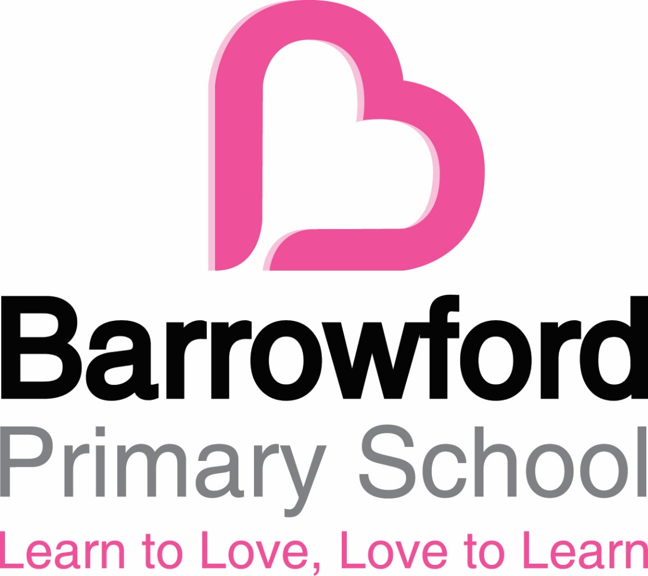

Uniform Policy



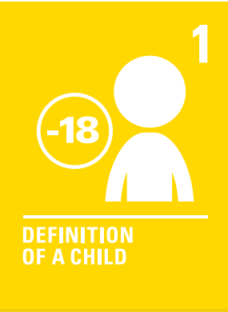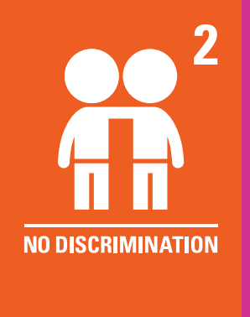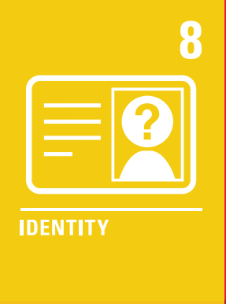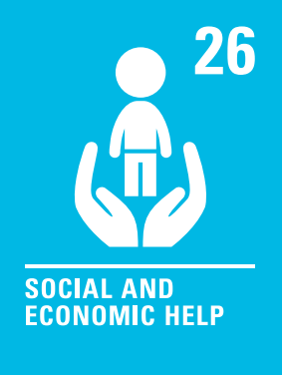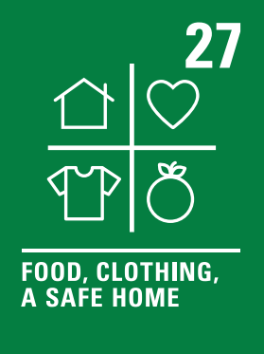

Barrowford Primary School: Uniform Policy
Introduction
At Barrowford Primary School, we believe that wearing a school uniform helps to foster a sense of belonging, pride, and community among our students. Our school uniform policy is designed to support a positive learning environment, where all children feel comfortable and focused. We ask that all children wear the uniform with pride, and we appreciate the support of our families in ensuring that the uniform is worn consistently.
We offer a variety of uniform items for purchase through the school, and we also encourage parents to make use of local shops and supermarkets where these items can often be found at competitive prices. A full list of required uniform items, including for Physical Education (PE) and outdoor activities, can be found below.
Aims and Objectives
Our uniform policy is based on the belief that school uniform:
- Promotes a sense of pride in the school and its values.
- Encourages a sense of community and belonging.
- Identifies children with the school.
- Supports our commitment to inclusion and equality.
- Minimizes distractions caused by ‘fashion clothes’ and encourages focus in the classroom.
- Is practical, comfortable, and designed with health and safety in mind.
- Provides good value for money, ensuring that families can purchase items affordably.
Jewellery, Hair Ornaments, Make-up, and Nail Varnish
For the safety and well-being of our students, we ask that children refrain from wearing jewellery during school hours. However, we recognize the importance of personal expression and allow the following exceptions:
- Small stud earrings in pierced ears.
- A wristwatch.
- Religious jewellery, which can be discussed with the Headteacher if needed.
Children are asked to remove any jewellery during PE lessons to prevent injuries, and teachers are not permitted to remove earrings.
Hair accessories such as hair bands, ribbons, bows, and scrunchies are welcome. However, we request that make-up and nail varnish are reserved for out-of-school activities, such as school discos or other special events.
Footwear
To ensure the health and safety of all our students, we ask that children wear plain black shoes or smart black trainers. For their safety, platform soles or high-heeled shoes are not permitted. We encourage shoes that are practical and suitable for both classroom activities and outdoor play.
The Role of Parents
We value the partnership between school and home, and we ask that parents ensure their child wears the correct school uniform, keeping it clean, in good condition, and clearly labeled with the child’s name. We understand that, at times, families may face challenges in fulfilling uniform requirements, and we encourage parents to contact a senior member of staff confidentially if any support or assistance is needed.
We also welcome children from all backgrounds, faith communities, and with special educational needs and disabilities (SEND). If there are special circumstances—such as religious beliefs or SEND needs—that require a variation from the standard uniform, we will be happy to discuss these requests and make reasonable adjustments where possible. Our goal is to ensure every child feels included and comfortable while maintaining the values of our school community.
The Role of Governors
The governing body plays an important role in supporting the Headteacher in the implementation of the school uniform policy. Governors ensure that the policy is fair, inclusive, and meets the needs of all children. They also consider feedback from parents and work closely with the Headteacher to review the policy regularly, ensuring it continues to support the overall values and needs of the school community.
Monitoring and Review
The school’s uniform policy is regularly reviewed by the governing body. This includes:
- Gathering feedback from parents and carers to ensure the policy continues to meet the needs of the community.
- Considering any requests for special dispensation regarding uniform for individual children, in consultation with the Headteacher.
School Uniform List
Our school uniform is primarily grey, and most items can be purchased from a variety of suppliers, including local supermarkets, children's clothing stores, or second-hand retailers. A detailed list of uniform requirements is outlined below.
Main School Uniform
- Grey jumper, hoody, or cardigan (branded items are optional and can be purchased from our online shop – see link below).
- White polo shirt.
- Grey trousers, skirt, dress, or shorts.
- Any colour summer dress.
- Black shoes or smart black trainers.
- A warm, waterproof coat (essential for outdoor play in all weather conditions).
PE Kit
- Grey jumper, hoody, or cardigan (as above).
- White T-shirt.
- Black shorts, joggers, or leggings.
- Black trainers.
Woodland Kit (for outdoor activities)
- Grey jumper, hoody, or cardigan (as above).
- White T-shirt.
- Black shorts, joggers, or leggings.
- Wellington boots.
- Warm waterproof coat (for winter).
- Sunhat (for summer).
- Waterproofs (optional).
Purchasing Uniform
Parents may choose to purchase uniform items from any supplier, including local supermarkets, children’s clothing stores, and second-hand retailers, which offer a great sustainable option. As long as the items are in the appropriate school colours (grey, white, and black) and do not feature logos, they are perfectly acceptable.
For families who wish to purchase branded uniform items, these can be ordered online through our dedicated school uniform provider:
Barrowford Primary School Uniform Shop

http://www.yourschooluniform.com/schools/index/barrowford-primary-school-3526

