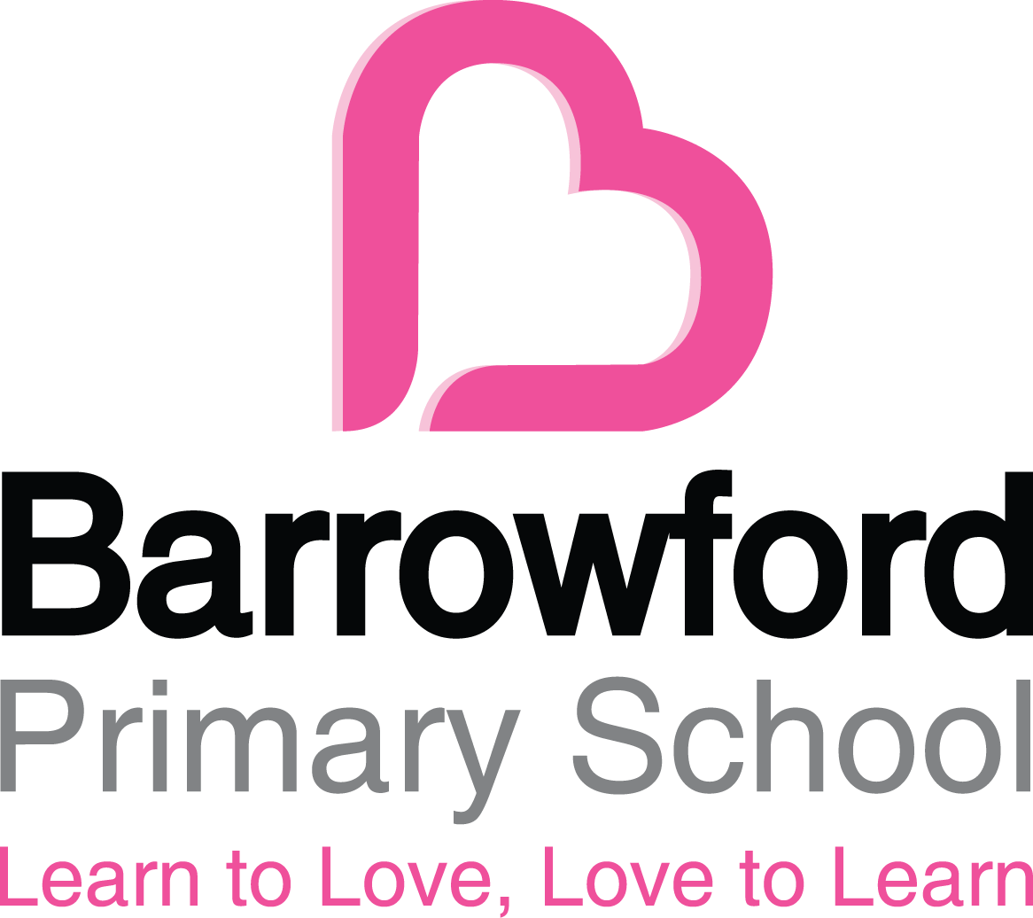

EYFS Policy

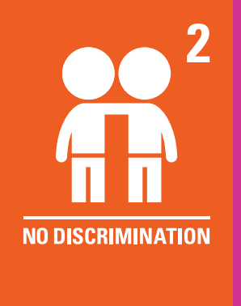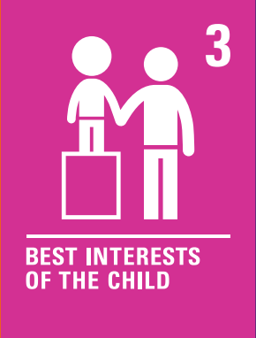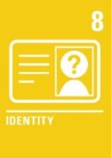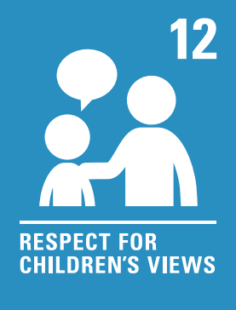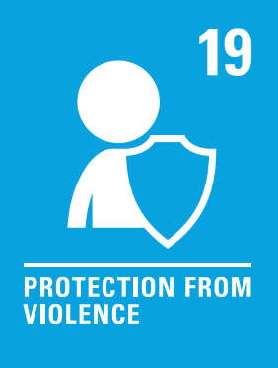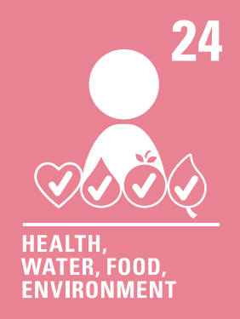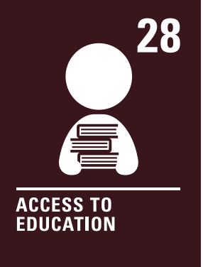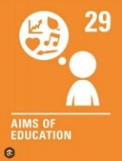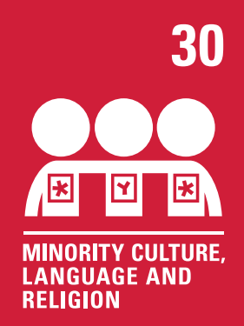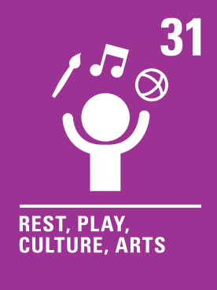

- Principles and Aims

Barrowford School aims to provide the highest quality care and education for all of its children. It aims to give them a strong foundation for their future learning. Every child deserves the best possible start in life and the support that enables them to fulfil their potential. We want to provide children with the key skills that will enable them to become lifelong learners.
Barrowford School adheres to the following EYFS guiding principles:
- Every child is a unique child, who is constantly learning and can be resilient, capable, confident and self-assured.
- Children learn to be strong and independent through positive relationships.
- Children learn and develop well in enabling environments with teaching and support from adults, who respond to their individual interests and needs and help them to build their learning over time.
- Children benefit from a strong partnership between practitioners and parents and/or carers.
- Quality and consistency in teaching and learning so that every child makes good progress and no child gets left behind.
- Children access a broad and balanced curriculum across the seven areas of learning and development highlighted in the Statutory Framework recognising that all areas are important and interconnected.
- There are equal opportunities and anti-discriminatory practice, ensuring that every child is included and supported.
- Where pupils require support, we provide early interventions.
- Children are regularly assessed and next steps are planned accordingly.
- Children have a key person/worker as an approach to developing a relationship with individual children, to understand their learning and to tailor this to children’s individual needs, and to build their confidence and support their wellbeing.
- Children access a secure and safe environment indoors and outdoors for learning and play.

All learning is underpinned by the good teaching of basic skills in Maths and English where teachers ensure that each child's next steps are identified and they are challenged appropriately to make progress in line with national expectations.
Our relationship policy is not primarily concerned with rule enforcement. It is a tool used to promote good relationships, so that people can work together with the common purpose of helping everyone learn.
Our school uses restorative approaches to encourage everyone to take responsibility for their behaviours.
We meet all legal duties under the EYFS Statutory Framework, including safeguarding and welfare requirements, staff qualifications, ratios, health and safety, and assessment expectations.
Legislation

The policy is based on requirements set out in -
- Early Years Foundation Stage Statutory Framework, Department for Education (DfE), dated 14th July 2025, effective 1st September 2025. This Policy is in accordance with the statutory framework for the EYFS framework covers the education and care of all children in early years provision, including children with Special Educational Needs and Disabilities (SEND).
We adhere to all mandatory EYFS welfare requirements, including safeguarding procedures, staff checks in line with KCSIE, paediatric first-aid requirements, data protection, and health and safety legislation.
EYFS statutory framework for group and school-based providers

- Induction and transitions

Planning for a smooth and thorough induction starts well in advance of the September start date. We endeavour to build new relationships with our new families that join us by providing the following -

- Each new starter is assigned a ‘Buddy’ (from Year 6) and a Key Person from the EYFS staff team.
- We hold an induction meeting for new families in May and the Year 6 buddies will show the families around our school and the families can meet their child’s Teacher and Key Person.
- Staff visit as many pre-schools/nurseries as possible to meet children in a familiar setting.
- We hold a series of ‘taster’ sessions in June for children to come and learn in the classroom.
- In July, we have a face to face meeting between the Teacher and Key Person and each family to discuss their child and their needs in more detail.
- Children attend school full-time from their start date in September.

Transition arrangements follow statutory guidance to ensure continuity of learning, secure information sharing and parental involvement.

For transition between EYFS and Year 1:

- Staff plan for more structured activities to be undertaken during the summer term, encouraging less dependence on adult support.
- EYFS and some Year 1 pupils remain mixed together in the same unit with the same staff.
- EYFS children will access teaching underpinned by the early years statutory framework, whereas children in Year 1 will access teaching underpinned by the National Curriculum.
- Discreet phonics, literacy and maths lessons are delivered for EYFS and Year 1.

- Staffing and structure of EYFS

Barrowford School has two Reception / Y1 classes. (max. of 30 in each class)
We comply with statutory staffing ratios at all times: at least one Level 3 practitioner and at least 50% of staff holding a Level 2 or higher qualification. Reception classes are led by a qualified teacher.
At least one person with a full paediatric first aid (PFA) certificate is always available as required by statutory guidance.
To ensure best practice, we have two class teachers, and one Key Worker attached to each class. In addition to this, we have support staff, who are classed as ‘Interveners’ who work within the classes, and provide extra support and intervention, where needed. Each child is assigned a key person to help to ensure that their learning and care is tailored to meet their individual needs. We ensure that children are within sight or hearing of staff at all times, as required by the EYFS statutory framework.
Children learn through a balance of child-initiated or adult-led activities. We encourage child initiated activities and adapt our continuous provision accordingly throughout the year. Children have the choice of where and how they choose to learn. All activities and resources are based upon current assessment and all have a main learning intention that can be accessed with or without adult support. In the beginning of Autumn term our continuous provision is basic and all adults model how to play and learn. There is a particular focus on the prime areas of learning and we focus on their interests.
When children are ready for challenge, we enhance the continuous provision and have focussed tasks alongside child initiated learning. In Spring, we make more enhancements with areas in need of development. Children begin completing independent activities as well as guided and child initiated. We set higher expectations. By the Summer term more area have specific challenges. There is an expectation of ELG’s and adults learn with target children.
Children have access to our indoor and outdoor classroom throughout the school day. Staff enhance our provision through objects, prompts, conversation and questioning. The learning environment is divided into different areas, in order to fully support all seven areas of learning. We believe that the outdoors environment is a vital part of children’s daily learning and we strive to ensure that all elements of the EYFS are reflected in our outdoor areas including a woodland area, whereby children can learn through real-life contexts, responsibility and care.

- Learning and development

Our early years setting follows the curriculum as outlined in the 2025 statutory framework for EYFS. Our curriculum meets all statutory learning and development requirements, including daily phonics, reading opportunities, and planned progression towards the Early Learning Goals.
The EYFS framework includes 7 areas of learning and development that are equally important and inter-connected. However, 3 areas known as the prime areas are seen as particularly important for igniting curiosity and enthusiasm for learning, and for building children’s capacity to learn, form relationships and thrive.
The prime areas are:
- Communication and language
- Physical development
- Personal, social and emotional development

The prime areas are strengthened and applied through 4 specific areas:
- Literacy
- Mathematics
- Understanding the world
- Expressive arts and design

Achievement of these prime and specific areas of learning is through the characteristics of effective learning:
- Playing and exploring
- Active learning
- Creating and thinking critically

- Planning

Staff carefully plan activities and experiences for children that enable children to develop and learn effectively. In order to do this, practitioners plan an exciting and challenging curriculum teaching discreet skills from the 7 areas of learning and development. These skills are planned carefully across the year through the delivery of different projects and themes.
Staff also take into account the individual needs, interests, and stage of development of each child in their care, and use this information to plan a challenging and enjoyable experience. Where a child may have a special educational need or disability, staff consider whether specialist support is required, linking with relevant services from other agencies, where appropriate.
In planning and guiding children’s activities, practitioners reflect on the different ways that children learn and include these in their practice.
We meet the statutory requirement to consider whether a child has SEND and to provide appropriate support or referrals.

- Teaching

Each area of learning and development is implemented through planned, purposeful play, and through a mix of adult-led and child-initiated activities. Practitioners respond to each child’s emerging needs and interests, guiding their development through warm, positive interaction. This is lead and monitored by the class teachers.
Children will access daily ‘carpet time’ lessons before practising previously taught skills within a play based environment.
We embed continuous provision to sustain engagement, foster independence and promote deeper learning. Our environment is designed to meet curriculum goals.
As children grow older, and as their development allows, the balance gradually shifts towards more adult-led activities to help children prepare for more formal learning, ready for year 1.
We ensure teaching is developmentally appropriate and aligned with statutory expectations for gradual preparation towards Year 1.

- Assessment

At Barrowford School, ongoing assessment is an integral part of the learning and development processes.
The Reception Baseline Assessment (RBA) is a short assessment, taken in the first six weeks in which a child starts reception.
During the year, staff observe pupils to identify their level of achievement, interests and learning styles. These observations are used to shape future planning and next steps of learning.
Class teachers will assess children’s early reading skills through half termly phonics assessments. This will inform next steps in reading.
Practitioners use the Development Matters document as a guideline to highlight the areas in which a child is on track and progressing well and the areas in which additional support is needed.
At the end of the EYFS, staff complete the EYFS profile for each child. Pupils are assessed against the 17 early learning goals, indicating whether they are:
- Meeting expected levels of development
- Not yet reaching expected levels (‘emerging’)
The results of the profile are then submitted to the local authority as required by the law and shared with parents/ carers.
Parents/carers are kept up to date with their child’s progress and development. Parents/carers attend a parents’ evening on, at least, two occasions during the year and a progress report is sent at the end of the year.

- Inclusion and Equality

Barrowford School is committed to supporting the individual needs, interests, and stage of development of each child in its care. The School has created a welcoming environment that is both safe and stimulating allowing its pupils to learn and grow in confidence. Where a child may have SEND, the School’s Special Educational Needs and Disability Coordinator (SENDCo) provides support and guidance and works with staff and parents/carers to consider whether specialist support is required, linking with relevant services from other agencies, where appropriate. The School looks to identify additional needs and provide additional support as early as possible so that the child gets the support that they need.
In EYFS we create an environment where every child, regardless of background, abilities or needs feels valued and respected and has equal opportunities to play and learn. All children are welcomed by being introduced to our class values based on being kind, calm and safe.
We fulfil the statutory duty to make reasonable adjustments, follow the SEND Code of Practice and support early identification of needs.

- Working in partnership

We value our partnerships and endeavour to actively maintain these by sharing information, ideas, expertise and our knowledge within our team and with parents, carers, colleagues and other professionals.
Within our role of enabling partnerships we:
- hold informal discussions with the EYFS team to discuss assessments, planning, individual children and current relevant research
- invite families to a class lunch every term
- send a weekly newsletter
- have reading records where comments can be shared
- encourage relevant home learning tasks to be continued at home to ensure that experiences at home are used to develop learning in the school
- operate an “open door” policy, whereby parents can come and discuss concerns and developments in an informal manner
- parents’ evenings
- end of year reports
- work with the local community to develop learning opportunities within the curriculum
We meet statutory parental engagement duties, including sharing progress and discussing safeguarding or SEND matters where required.

- Safeguarding and Welfare

The safeguarding and welfare of children is of paramount importance and the School takes all necessary steps to keep children safe and well. In order to fulfil its duties and responsibilities, our safeguarding and welfare procedures are outlined in our safeguarding policy.
All EYFS safeguarding requirements are met, including safer recruitment, staff checks, health and safety, supervision ratios, paediatric first aid, risk assessment and policies required under the EYFS framework.
We ensure health and safety in EYFS is a priority. Please refer to the health and safety policy. Designated paediatric-trained First Aiders are displayed clearly in each classroom and on the outside doors.
Children eat snack and lunch in their classrooms. During this time, there will always be a First Aider in class.
Barrowford School is a healthy school and all children in EYFS have access to free fruit. Where children are provided with meals, snacks and drinks, these are healthy, balanced and nutritious. Fresh water is always available for children to drink. Parent/carers are required to provide the School with details of any special requirement, preferences and food allergies and any special health requirement, where applicable. This information is recorded and acted upon. We are also a nut-free school.
Our Relationship policy outlines the relationship-based approach we have towards behaviour. We help children to learn how to communicate their needs more effectively. We help children develop an understanding about intrinsic motivation and staff use restorative approaches. We have high expectations and insist on high standards of behaviour.

- Monitoring arrangements

This policy will be reviewed and approved by Rachel Tomlinson every year.
At every review, the policy will be shared with the governors.

