bi


Bio Metric Data



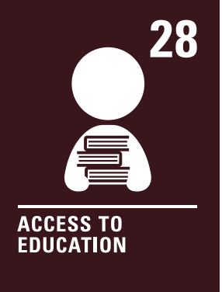

Statement About the Processing of Biometric Data
At Barrowford School, we prioritise the privacy and security of personal data. We confirm that the school does not store or process any form of biometric data, such as fingerprints or retina scans.
This position complies with the UK General Data Protection Regulation (UK GDPR) and the Data Protection Act 2018, which govern the collection, storage, and use of personal data.
The governing board and the school’s Data Protection Officer (DPO) will review this statement annually to ensure it remains up to date and compliant with legal requirements. The next scheduled review will take place in Autumn 2026.
If the school were to consider storing or processing biometric data in the future, a thorough consultation would be carried out with staff, parents, and pupils. A clear policy outlining the purpose, use, and safeguards for biometric data would be developed and published on the school website. Stakeholders would also be informed of their rights, including the option to opt out of any biometric data processing.
We are committed to transparency and will communicate any changes to this position promptly to all staff, parents, and pupils.
If you have any questions about this statement or require further information, please contact the Headteacher via the school office on 01282 615644.

