Welcome to
Sonder

Barrowford Primary School


Learn To Love, Love To Learn

2025 - 2026

Our adults
In Sonder your adults are;

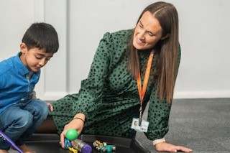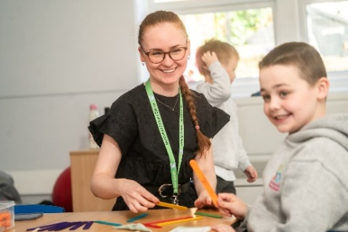
Mrs Trapanese Miss Roadway

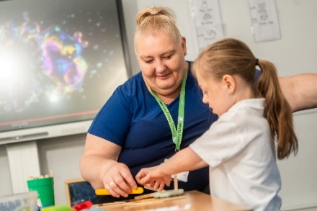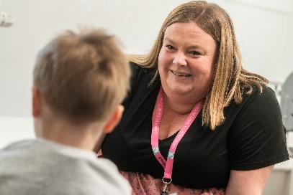
Miss Lynne Miss Wilkinson

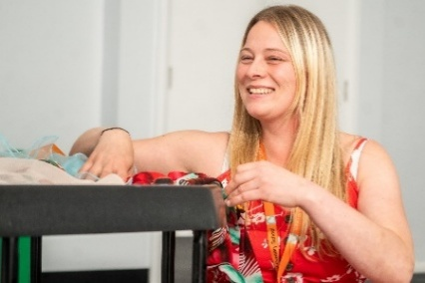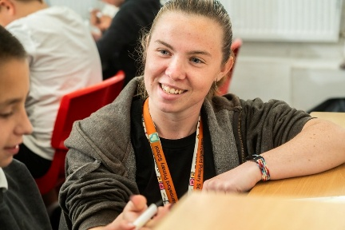

Miss Simpson Miss Summer

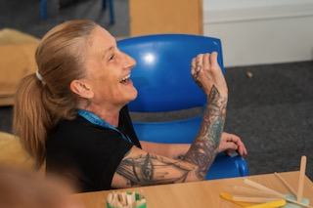
Miss Crabtree

They are excited about the learning you are doing in this year group.

Learning Time

There will always be a visual timetable in the classroom.

This is what a day will usually look like in Miss Roadway’s class.

Register / check in / choosing / Intensive interaction

Sensory circuit

Guided reading

Hello song / bag time

Phonics / SALT interventions

Choosing time

Maths / English / EHCP targets

Play time / snack time

Choosing time / Sensory play

Story time

Lunch

Register / choosing time / Intensive interaction

Hello song / Bag time

SALT Interventions / Sensory play

Play time / Snack time

Story time

Home time

This is what a day will usually look like in Mrs Trapanese’s class.

Learning Time

Choosing time

Hello song / Bag time

Intensive interaction / sensory play

Snack time

Play time

Tac pac / SALT Interventions

Lunch time

Choosing time

Hello song / Bag time

Intensive interaction / sensory play

Music and schema

Snack time

Play time

Story time

Home time

PE / Woodland

Our PE session is Friday.
Our Woodland session is Friday.

The swimming pool is coming in November 2025.

Playtime

You will play Playworks games with your friends. These will teach you how to take turns, follow rules, lose and win well and be part of a team.

Lunchtime

You will order your lunch in the morning or bring a packed lunch from home.

A selection of school dinners are offered to all the children to taste and explore if they wish. There is no pressure to eat these foods if they do not want to.

At lunchtime, you will wash your hands and then eat your lunch in the classroom.

There will be some time to play out, playing Playworks games in Miss Roadway’s class.

Toilets

If you need the toilet, ask the teacher at a convenient time and we will happily show you where they are.

We have changing facilities for any children that are not yet toilet trained.

Trips, Visits & Celebrations

There will be a school trips linked to our projects.

People may visit our class to help with our projects or to support our learning.

We will celebrate Christmas, Eid, Fathers’ Day, Mothers’ Day, World Book Day, Harvest, Easter, birthdays and lots of other events during the school year.

End of the day

There will always be a story at the end of every day.

At home time, your teachers will take you onto the playground to meet your parents / take you to your taxi. Please make sure your teacher knows who you are leaving with at the end of the day.

